I3333 Project
Academic Year 2025-2026
Report

Team Composition
Project Title: Animated Solar System
Student Full Name: Patrick Farah
Student ID: 60338
Student Full Name: Charbel Fares
Student ID: 61116
Student Full Name: Bilal Hammoud
Student ID: 61105

Problem Description
A 3D animated project that aim to design and implement our Solar System, including the Sun, planets, moons (to some extent) and even stars, while also allowing the user to experience this in some way via a working camera to move and look around.
This topic was picked to help us push our limits in the most enjoyable, complex and interesting way possible, compared to other projects, this topic is the only project to steal our attention, and rightfully so, with how beautiful this project turned out, it was well worth it.
To achieve this however, multiple techniques were used, from self-made planet spheres, giving them the ability to rotate around a center point while spinning, giving the planets trails that fade after time, giving some planets moons and others received their rings, adding stars manually, to implementing an interactive camera and a working space background.

Methodology
Just speaking about what we were able to achieve isn’t enough, so we have to dive into each particular set and explain the mechanics and how they were made possible:
The Sun and Planets ( SPHERES ):
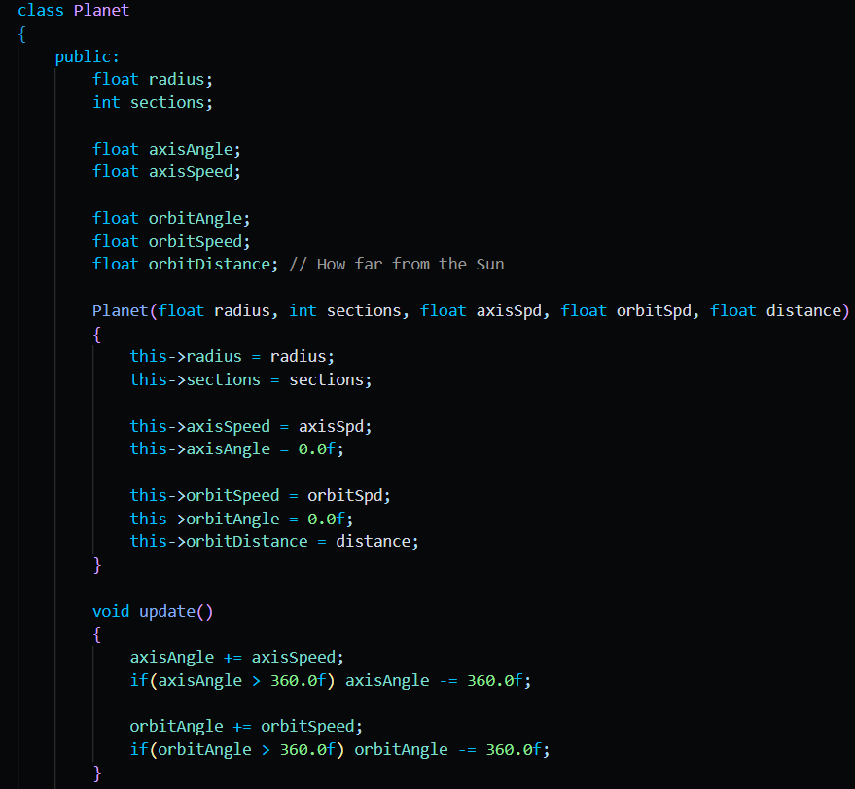
1a: Snippet Of Code From The Planet Class
When creating a planet via the Planet Class, we give it’s radius to determine how big the sphere actually is, sections to determine realism, axis speed which determines how fast the planet spins, orbit speed which determines how fast the planet orbits the sun, and the distance between the planet and the sun, using a continuous update() function whilst the program is running, we add the axis speed to the axis angle, and orbit speed to the orbit angle, which determines the rotation and the planet’s position in orbit around the sun respectively.
Gradient Colors For Planets:
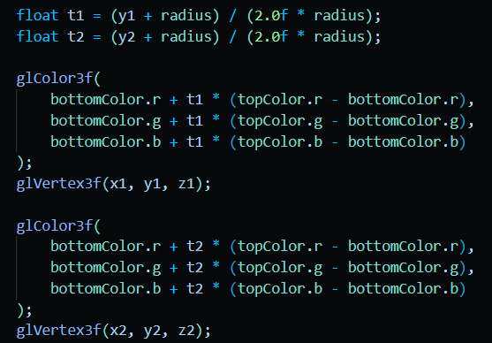
2a: The code used in the Planet class’s draw() function, gradient coloring part.
While drawing the sphere, the program checks the Y position of each vertex to know how high or low that point is on the planet. It then converts that height into a value called t, where 0 means the bottom of the planet, 1 means the top, and values in between represent points between them. This value is used to blend between the bottom and top colors using linear interpolation. Before each vertex is drawn, glColor3f() sets the calculated color for that vertex. OpenGL smoothly blends the colors between nearby vertices, creating a vertical gradient.
Orbit Trails:
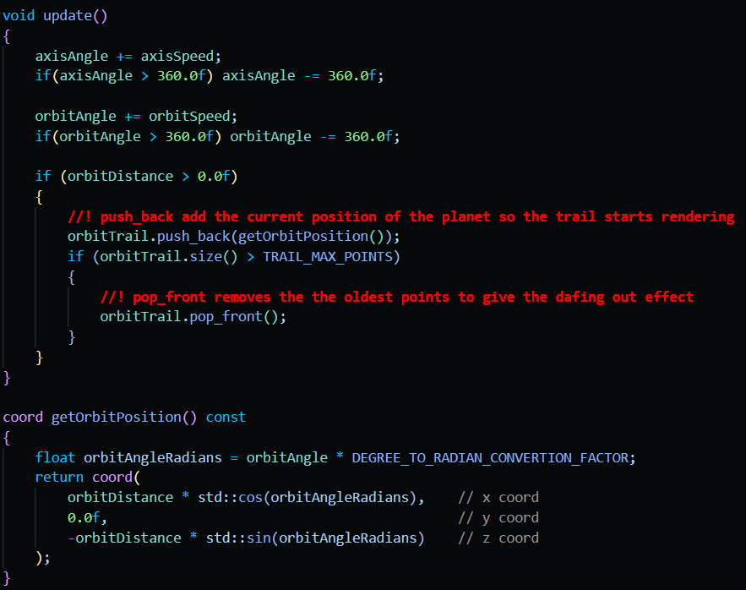
3a: A snippet of code showcasing how the orbit trail is updated constantly to make the fading effect.
The orbit trail works by storing the planet’s recent positions as it moves around the sun. Each planet has an orbitTrail, which is a deque that saves coordinate points. During every update, the planet’s orbitAngle increases, and the current position is calculated using cos and sin based on the orbit distance. This new position is added to the back of the trail, while older positions are removed once the trail becomes longer than TRAIL_MAX_POINTS (a limiter used to increase/decrease orbit length). When drawing the trail, the program uses GL_LINE_STRIP to connect all the saved positions into one continuous line. Each point is drawn with glColor4f, using alpha transparency so older parts of the trail appear faded and newer parts appear brighter.
Moons:
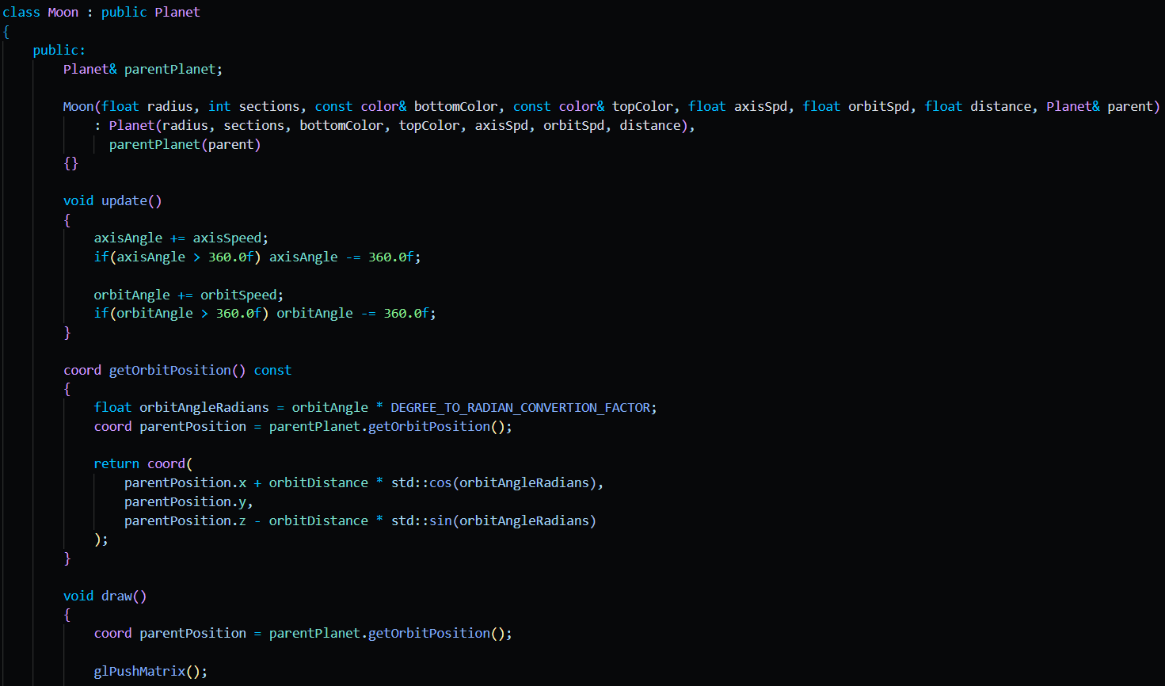
4a: A snippet of code from the Moon class, showcasing how it inherits from it’s parent Class and sets a parent planet to follow. Moons also possess orbit trails but are much smaller/weaker than that of planets.
The moon works by making the Moon class inherit from the Planet class, so it can reuse the same properties such as radius, orbit angle, orbit speed, axis angle, and drawing logic. The main difference is that each moon stores a reference to a parent Planet, which is the object it orbits. In getOrbitPosition(), the moon first gets the current position of its parent, then adds its own circular offset using cos and sin. This makes the moon follow the parent while still orbiting around it. When drawing, the code first translates to the parent’s position, then rotates by the moon’s orbit angle, moves outward by the orbit distance, and finally rotates the moon around its own axis, effectively making the Moon orbit the Earth which orbits the Sun in perfect harmony.
Planet Rings:
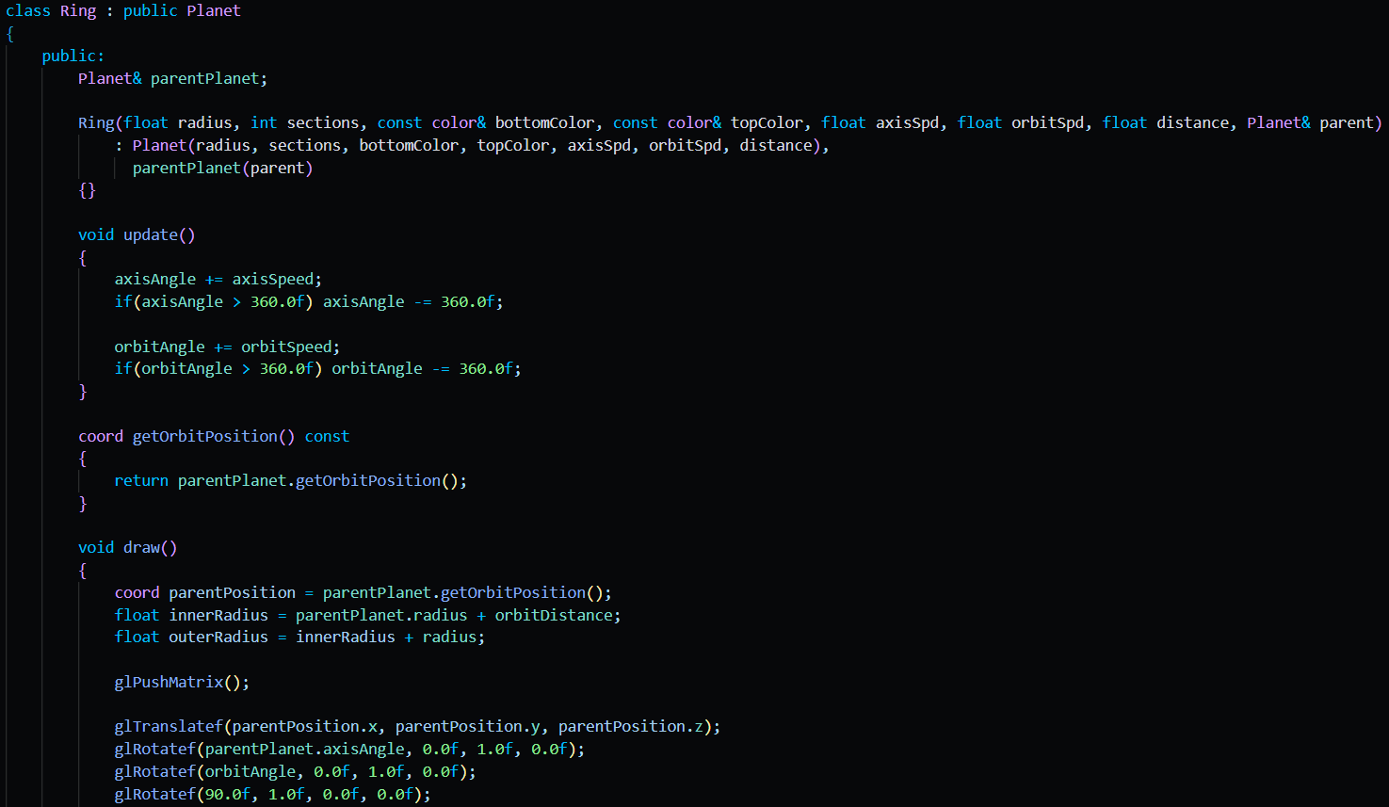
5a: A snippet of code from the Ring class, works almost the same as the Moon class.
The planet ring works by creating a Ring class that inherits from the Planet class and stores a reference to a parentPlanet. This allows the ring to follow the planet it belongs to. In the draw() function, the ring first gets the parent planet’s current position, then calculates an innerRadius and outerRadius to control the ring’s thickness. The code uses glTranslatef() to move the ring to the planet’s position, then applies rotations so the ring is placed correctly around the planet. The ring itself is drawn using GL_QUAD_STRIP, the circular shape is made using cos and sin, and connecting all the inner and outer points creates a flat band around the planet.
Stars:
Photo & Text
Space Background (Skybox):
Photo & Text
Interactive Camera:
Photo & Text

Experimentations and Results
Result
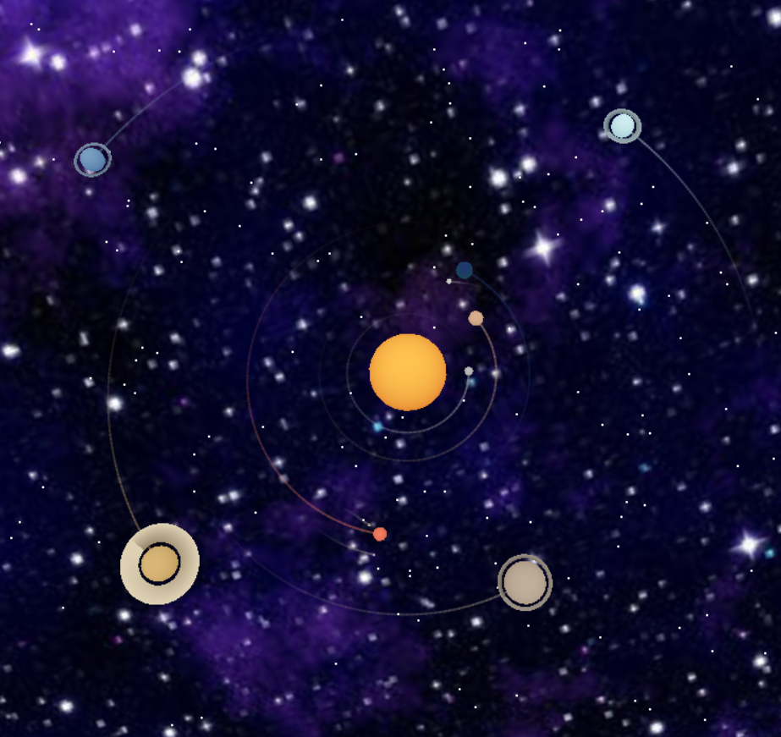
0: The result of all experiments combined, while also making the accurate representations of planets, moons and rings.
The 3D solar system suspended inside a galaxy skybox, with a glowing orange-gold Sun at the center and every planet sliding around it in its own orbit. Each planet has a soft vertical gradient, so Mercury looks dusty and pale, Venus feels warm and cloudy, Earth carries deep blue and green tones, Mars burns softly red, and the outer giants drift in cooler, heavier colors.
Planets rotate on their axes, orbit trails fade behind them, moons loop around Earth and Mars, and rings wrap around Jupiter, Saturn, Uranus, and Neptune. Around all of that, a thousand (literally) scattered stars and a textured skybox make the simulation feel less like a diagram.
And honestly, random glaze: this project is kind of majestic. The orbit trails are especially clean, the camera controls make it feel explorable instead of static, and the rings add that extra chef’s kiss.
Experiment Road:
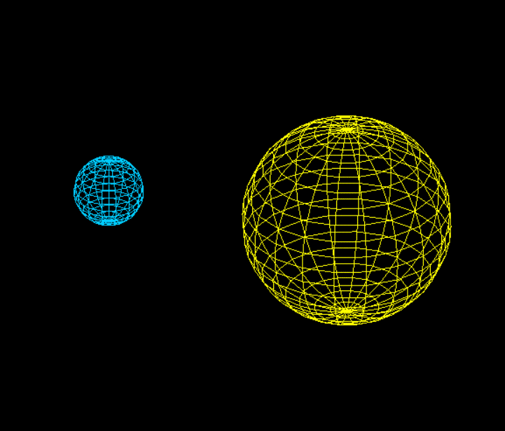
1b: The result of initial testing for the Planet class, showcasing a planet orbiting around the sun.
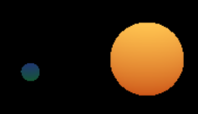
2b: The result of initial testing for Gradient Colors, showcasing the earth’s blue and green colors and the sun’s yellow and orange gradient.
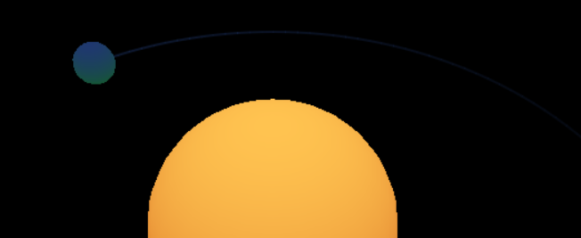
3b: The result of initial testing for Orbit Trials, showcasing a line the drastically fades behind the planet.
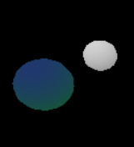
4b: The result of initial testing for Moons, showcasing how the moon orbits it’s parent planet. Keeps following the planet as it orbits the sun.
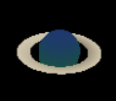
5b: The result of initial testing for Planet Rings, showcasing how the rings follow their parent planet as it orbits the sun.
P.S. The use of AI tools (e.g., ChatGPT, DeepSeek, etc.) must be clearly acknowledged in your report. Such tools may be used for assistance, inspiration, or fixing grammar, but not for the full redaction of the report.

